Question 1:

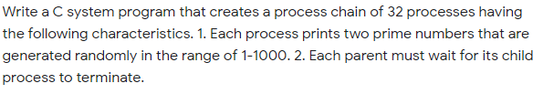

Question 2:

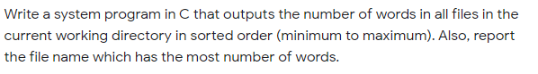

Question 3:

